HCL App Submission - First Round

Table of Contents

1. Introduction 3

1.1. Purpose 3

1.2. Overview 3

2. App Details 4

2.1. Functionalities 4

2.2. Search 4

2.3. Display & Drill Down 5

2.4. Details 5

3. Technical Details 6

3.1. Technologies & Tools Used 6

# Introduction

## Purpose

At the outset, we would like to thank the CBA’s Office of CTO for providing HCL the opportunity to participate in the Coding Competition.

As part of the First Round of submission (the Fun Run) HCL is submitting the Application – “Location Based Financial Spend Pattern”.

## Overview

Study and analysis of Financial spend pattern based on different locations for a frequent travelling person will help a lot in better planning and managing his/her Financial needs. To facilitate a single view of the spend pattern a simple Web Application is designed to show data based on Geo / Location where the spending has occurred within a given time period. This further can be extended to provide analytics around the various parameters of spend to identify patterns.

As soon as the user (CBA account holder) logs into the web page and brings up the application the following will be displayed:

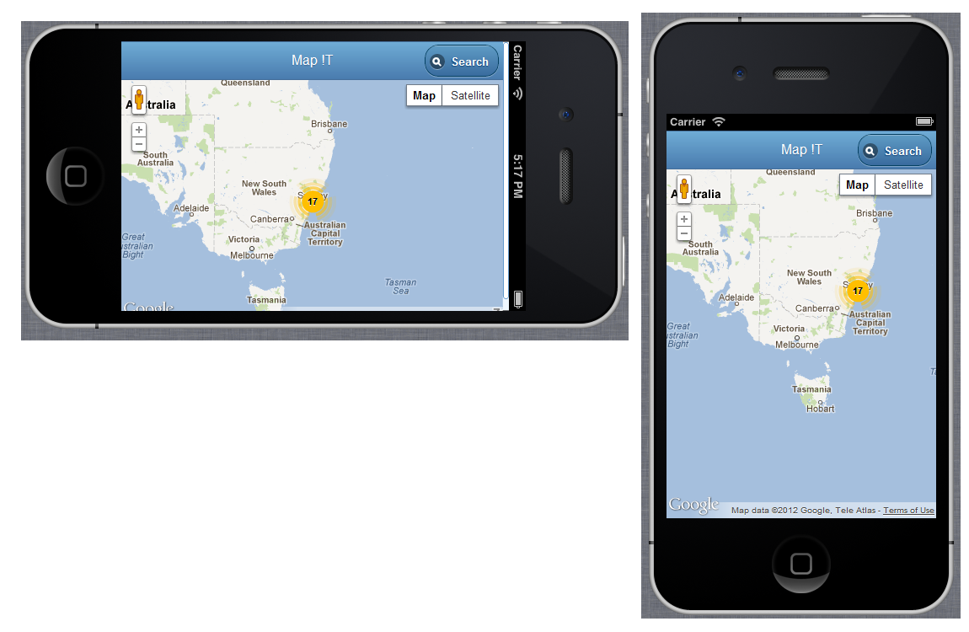

Fig – 1

# App Details

## Functionalities

The App provides the following functionalities at a high level for a user

* **Search** for spend pattern based on Account Type
* **Display & Drill Down** all spends based on locations in map
* **Details** of spend based on a given Location

## Search

The user from the Home page (refer Fig 1) can click on the Search button situated at the top right corner of the App.

This will bring up a Form where the user can enter data based on his account type and period of spend to identify the pattern for a specified time period.

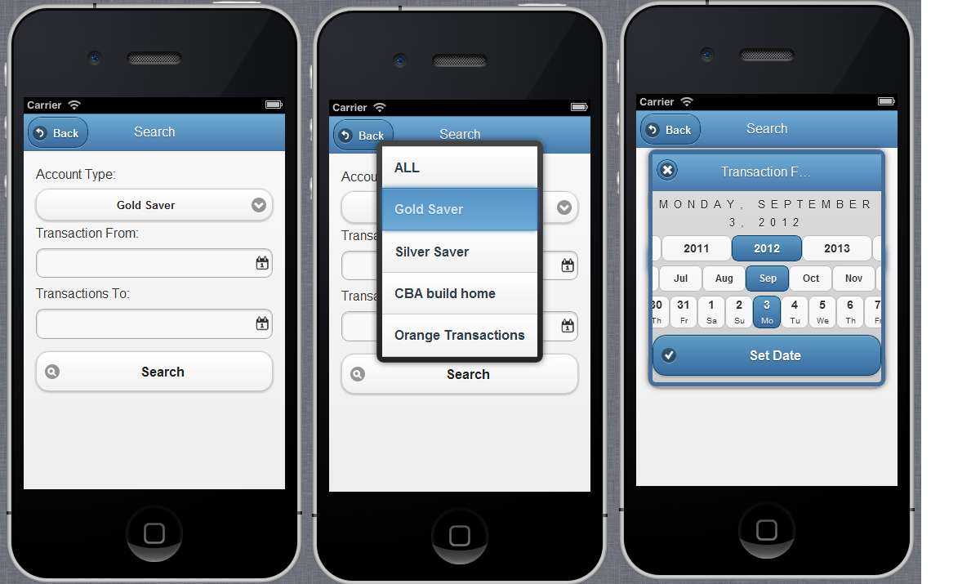

Fig – 2

The form can be submitted by pressing the Search button in this.

## Display & Drill Down

The Form entered with search details once submitted will provide the following view with respect to the geography / location where the spend has happened.

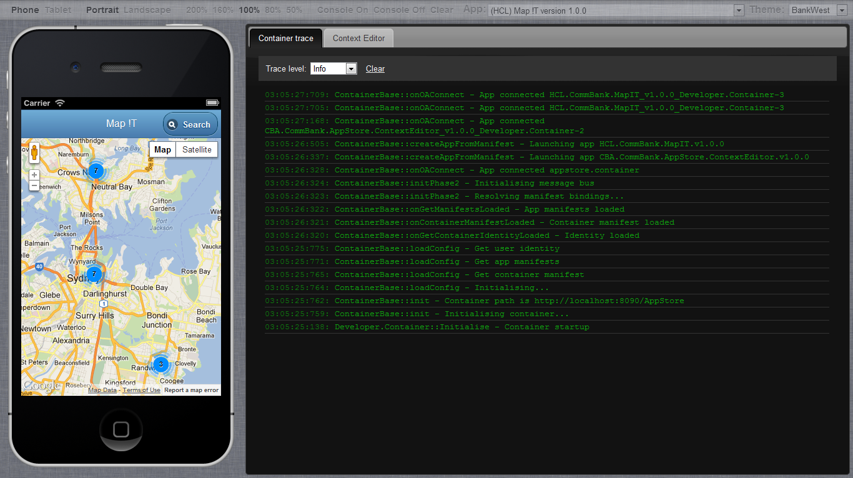

Fig – 3

In this the various spends that have happened for the user at different locations are highlighted with colored bubbles along with display of the number of transactions at that location.

The zoom-in facility of the map can be used to drill down to details. The drill down facility will be possible at continent, city and street levels for a given search criteria.

## Details

To get details of spend for a particular location, the respective bubble can be highlighted and the Details button on top left corner of the App can be clicked.

It then displays the following transaction details on a new page:

* Merchandise purchased
* Shop name and address
* Date of purchase
* Amount of transaction

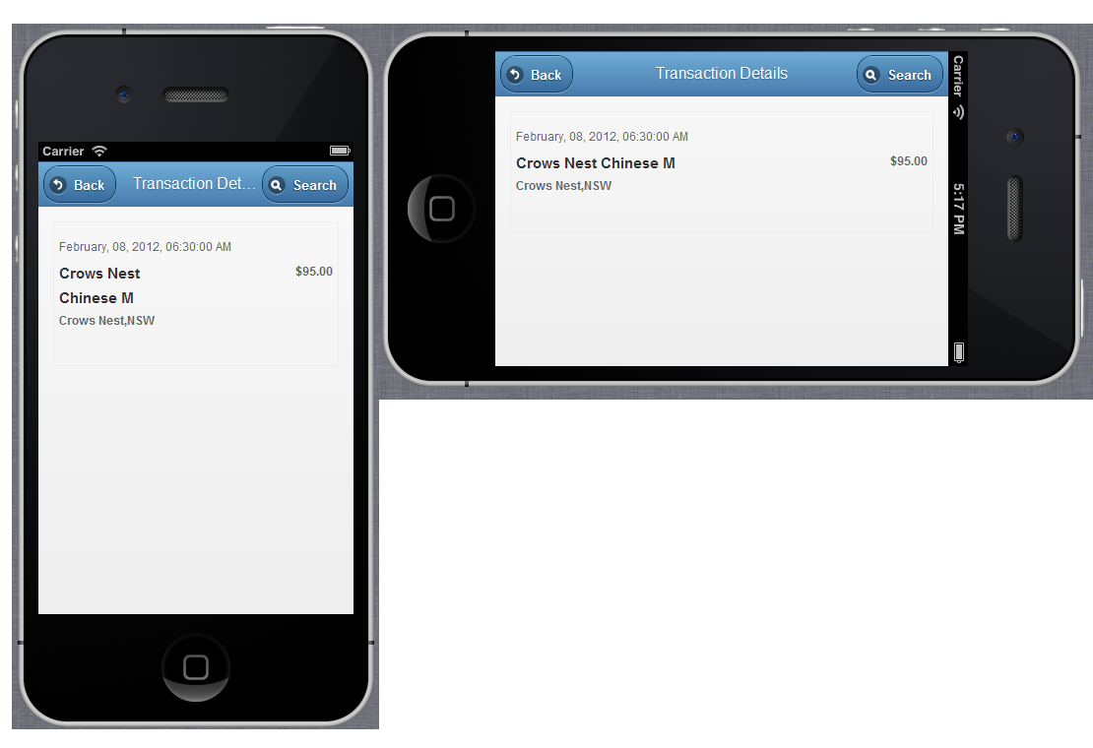

Fig – 4

# Technical Details

## Technologies & Tools Used

The Application is developed and integrated with the Developer Container provided by CBA in order to enable it to function as a part of the App Store.

The development is done using the following:

* HTML5
* JavaScript
* JSON
* CSS
* Google Map API
* JQuery, JQuery Mobile,JsRender